GIT & GITHUB

1.Install git.



2. Create a repo in github with README.md and .ignore file.

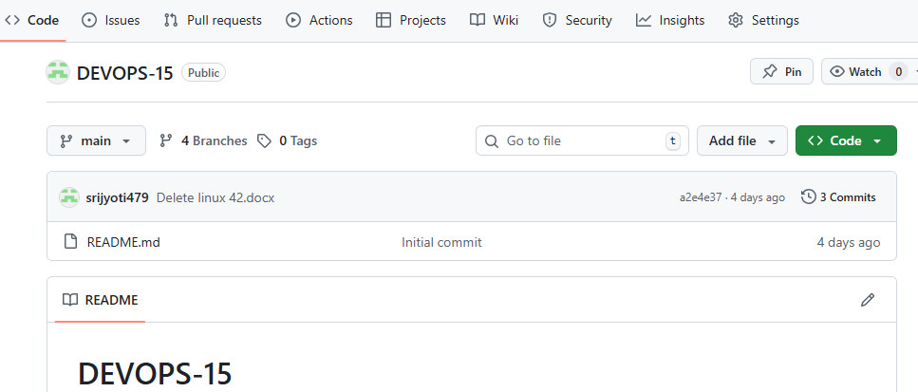

3. clone the created repo to local.

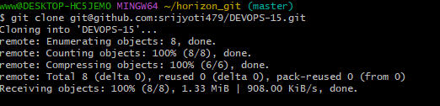

4. Create two files in local repo

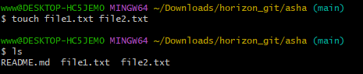

5. Commit two files and push to central repo.

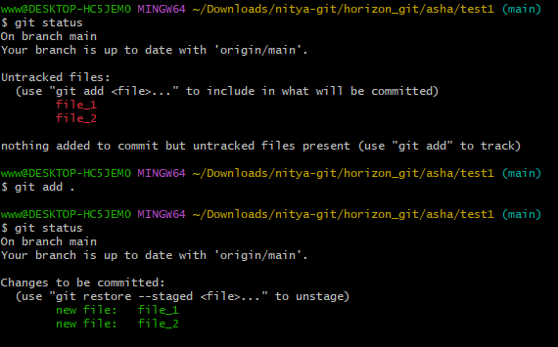

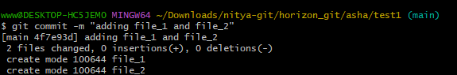

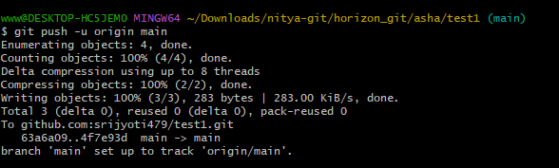

6. Create a branch in local and create a sample file and push to central.

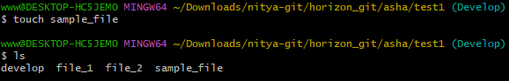

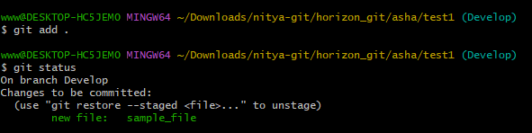

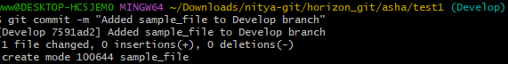

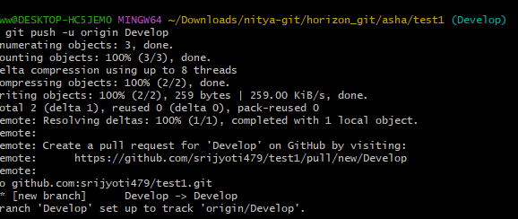

7. Create a branch in github and clone that to local.

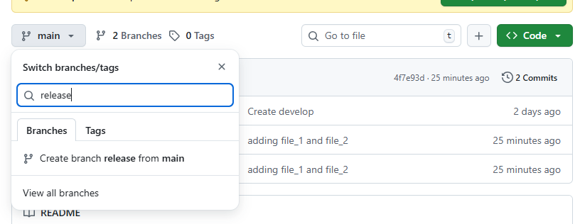

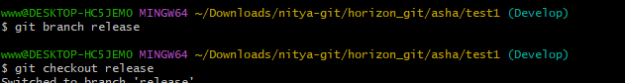

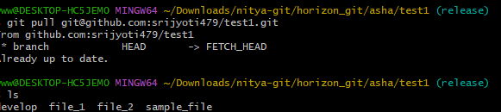

8. merge the created branch with master in git local.

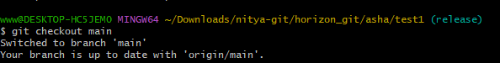

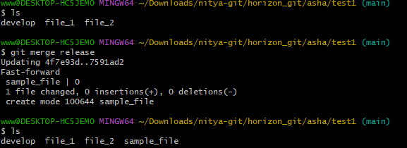

9. Merge the create branch with master in github by sending a pull request.

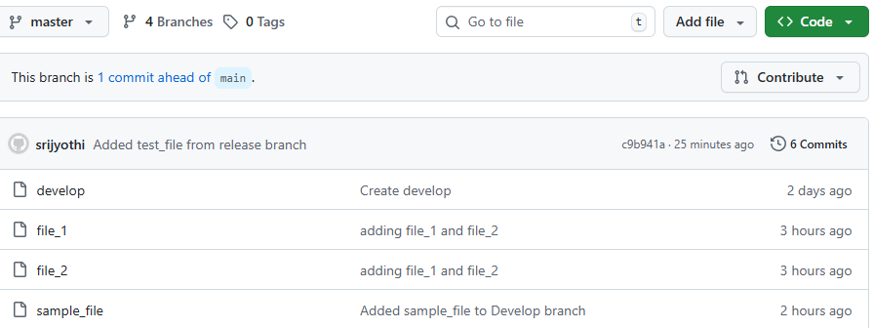

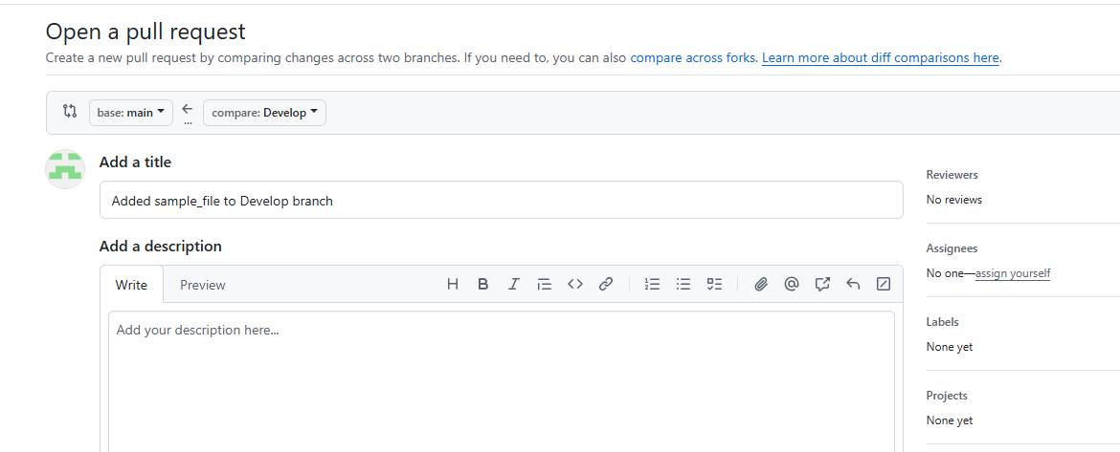

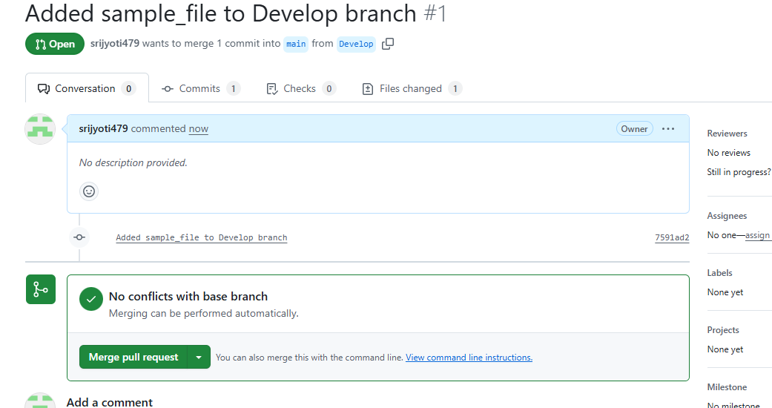

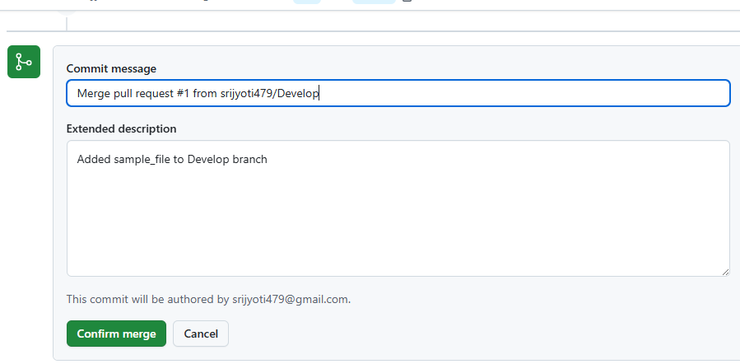

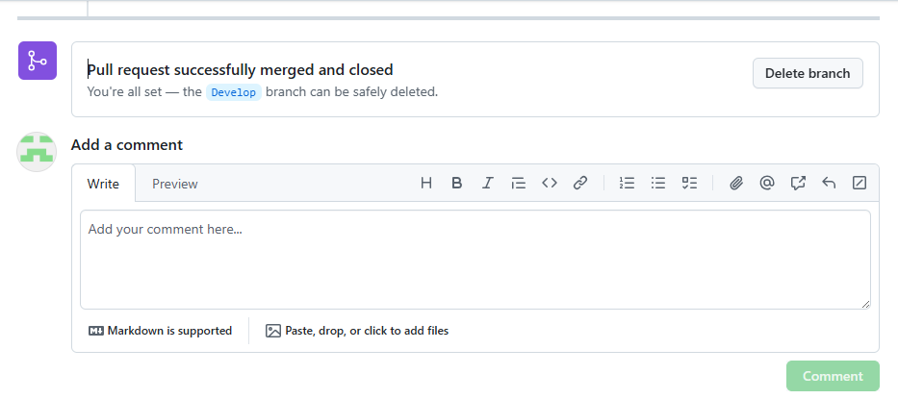

10. Create a file in local and send that to branch in github.

Use touch file_name to create a file



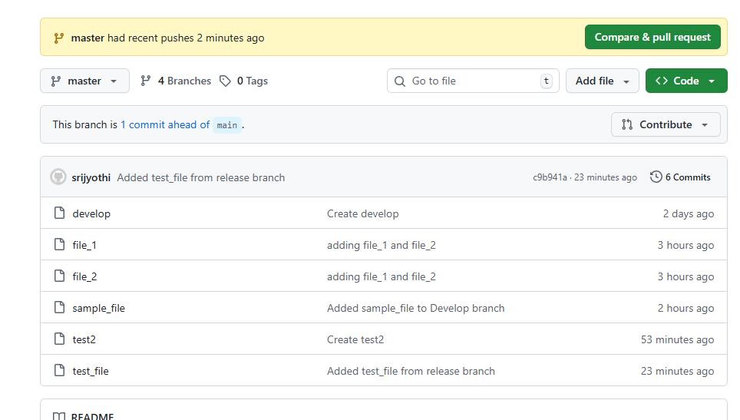

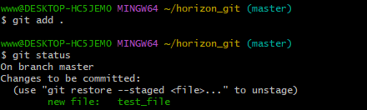

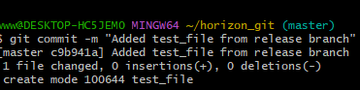

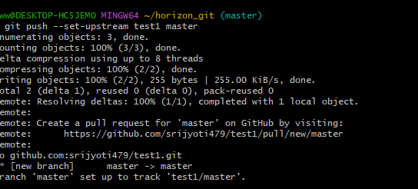

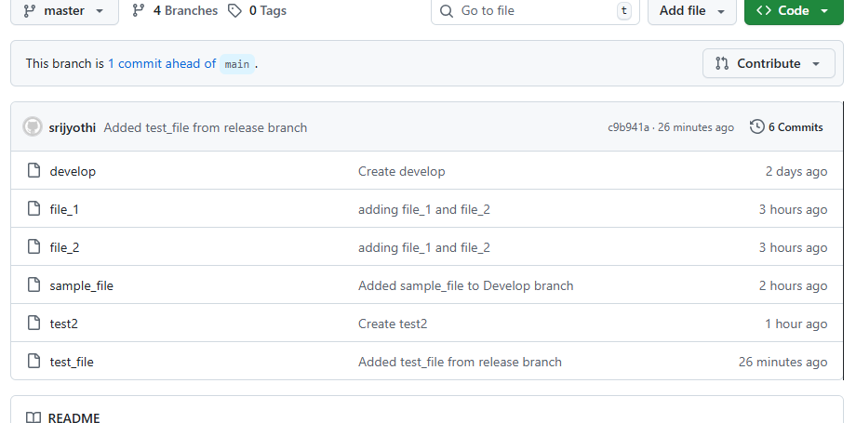

11. clone only a branch from github to local.

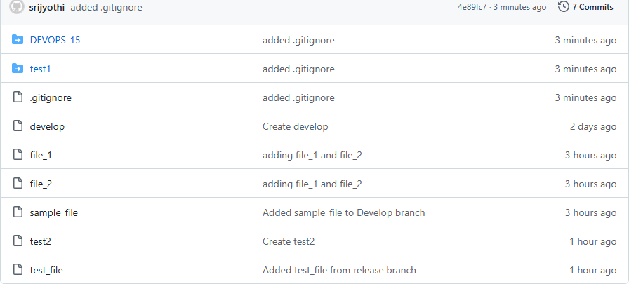



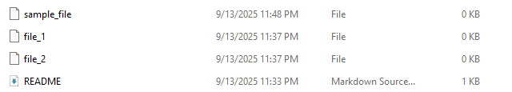

12. Create a file with all password and make that untrackable withgit.

Create a file containg password and check status



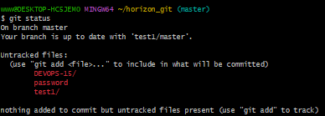



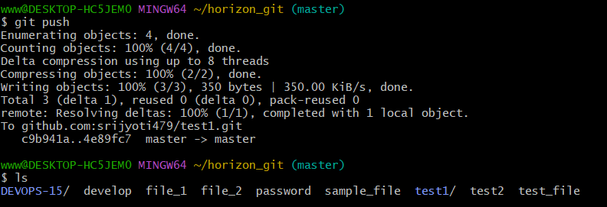

13. Make a commit and make that commit reset without savings changes.





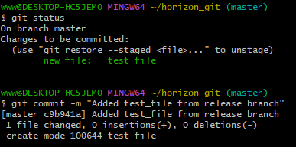

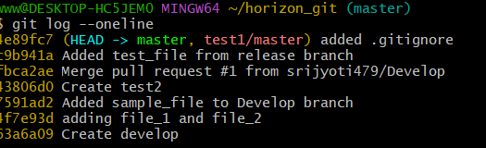

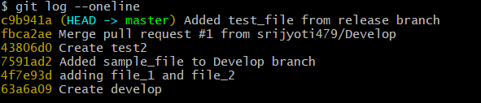

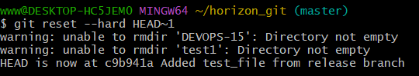

14. Revert a commited commit to the older version



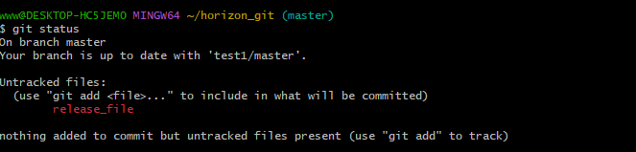

15. Push a file to stash savings the changes and work on another file.







16. Undo the stash file and start wirking on that again.

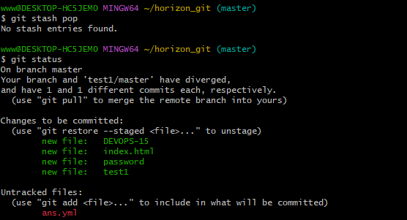

17.Generate a ssh-keygen and configure into github.

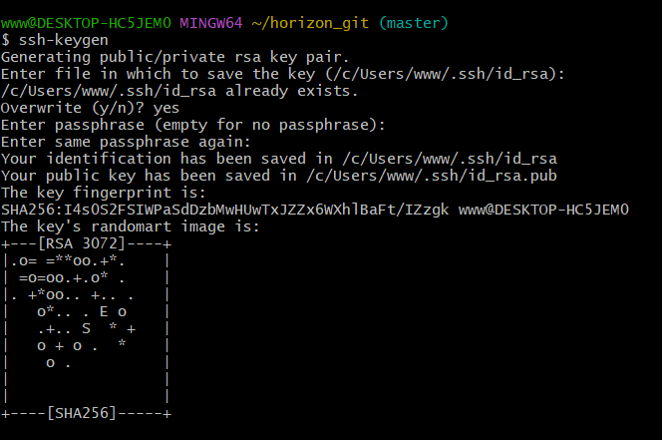

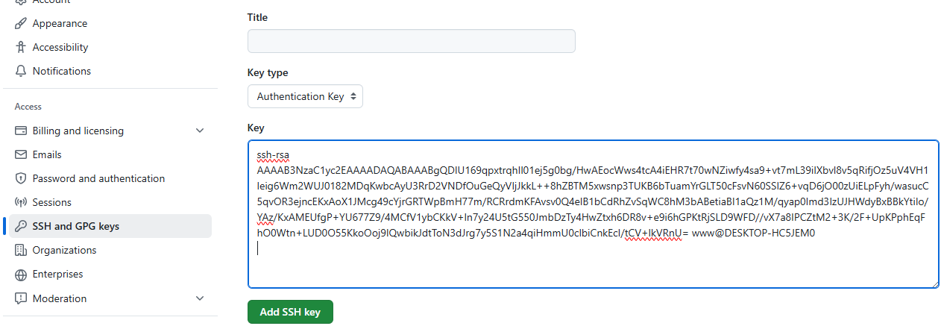

18. Configure webhooks to github.

Objective:NA

Procedure:NA

19. Basic understanding of the .git file.

Objective: to explain the .’git’ file with its contents.

Explanation :

The .git folder contains git’s metadata and object database.

Key files:

* HEAD: points to the current branch
* Config:repository-specific settings.
* Objects/:stores all commits, files, and trees.
* Refs/heads/:contains pointers to commits for each branch.

20. Check all the logs of git .

Use git log to check all log

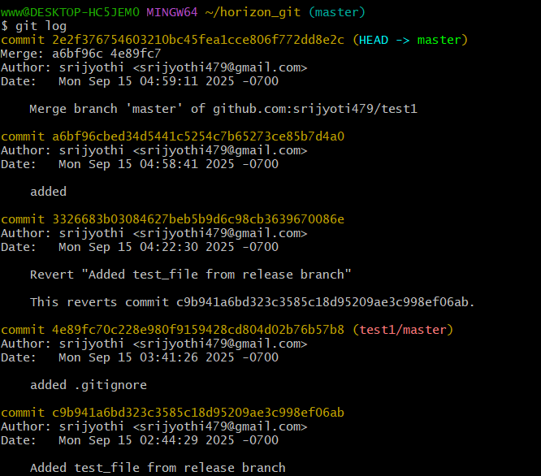

21. Rename the commit message.

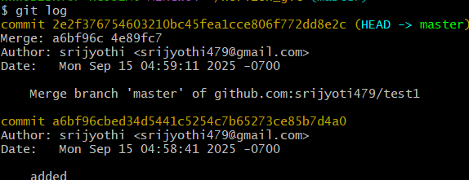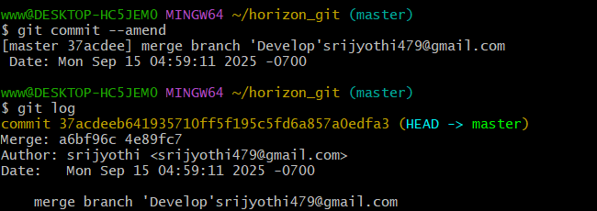

22. Merge multiple commit into single commit.

Use git rebase-l HEAD~4 and replace pic with squash



